Math 11 Foundations Name:_____________
Mark:____/25
Chap 1 First Assignment

A can of Coke has a volume of 355mL, which is a pretty weird number.
What is the volume of Coke in ounces (oz)?
(29.6mL = 1 oz)

Abottle of pop has a volume of 710mL.
This number seems a bit unusual.
What would the volume be in ounces (oz)?
(29.6mL = 1 oz)

Commercial coffee comes in sizes like Tall, or Grande.
A Tall coffee is usually 12 oz. How many mL is that?
(Haha- now compare it to a can of Coke and think about which is the better deal for caffeine!)
(29.6mL = 1 oz)

Mr. Marseille currently weighs 170lbs.
How many kilograms is that?

What is your height in centimetres?
What is your height in inches?

What is your height in feet and inches?

How long is your foot in centimetres?
How long is your foot in inches?


How long is your thumb to finger span?

In centimetres?
In inches?

How wide is your arm span?

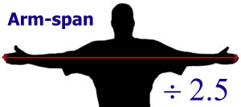
_____ cm

______ _____ inches

Mr. Marseille has a turkey to cook for the holidays.
His turkey weighs 6.4 kg.
His cookbook says to cook it for 12minutes per pound.
If dinner is at 5:00, what time does the turkey have to be in the oven to be fully cooked on time?

Mr. Marseille needs to replace the carpet in his living room
The dimensions of the room are 5m by 4.2m.
Carpet is sold by the square foot, and costs $5.20/ sq.ft.
How much will it cost her to buy new carpet?

On the lot plan below,
the back yard measurements are shown.
Back Yard
9.5m
12.2m

House
8.2m

How much fencing (in meters) would be required to completely surround the backyard?
(you don’t need to fence the back wall of the house!)
If fence materials are sold by the foot, how many feet of fencing is required?

A road trip from Vancouver to Santa Cruz (good surfing!) is 1008 miles.
How far is this in kilometres?
If your car has a fuel consumption of 8.4L/100km, how much gas will you burn on the trip (one way)?
Gas in the states is sold by the gallon. How many gallons of gas do you need? (1 Gallon = 3.8L)
Gas in the states costs $2.77per gallon.
How much would you spend on gas?
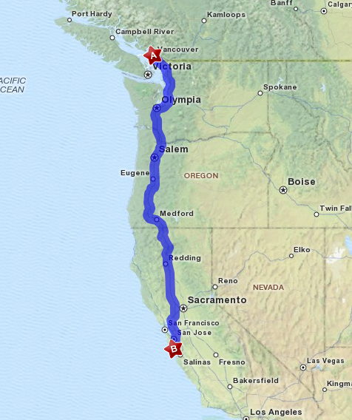

Name:________________ Date: ________
Pop can  ________ oz | Pop bottle  ________ oz
Coffee  ________ oz | Mrs. Marseille’s weight  ___________ kg
Your Height  ________ cm  ________ inches  ___ feet ____inches | Your foot  ________ cm  ________ inches
Your thumb to finger span  ________ cm  ________ inches | Your arm span  ________ cm  ________ inches
The turkey  ____________ pounds  ___________cooking time  Start cooking at ________ o’clock | Road trip!  _______ km  _______L of gas = ________ gallons  Cost $_______
The yard and fence  ______ meters of fencing  ______ feet of fencing | The carpet  _________ square feet  Cost $_________

