Photo Processing Activity
Photo 1 – Original
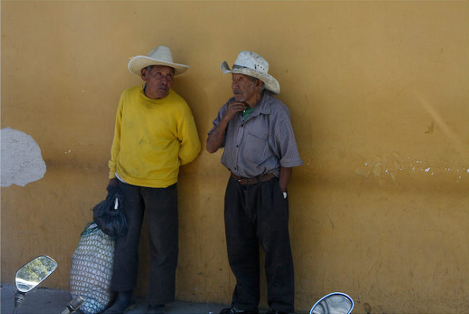
Message: This photo appears as though it was taken on vacation. These look like some local people from Central or South America. The scooter mirrors in the foreground show that the photo was taken fairly recently.
Photo 2 – Processed
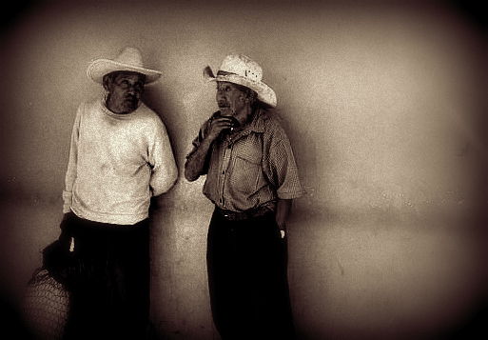
Message – The black and white effect gives the impression that this photo may be very old. The darker tones make the picture seem sadder than the original. The scooter mirrors are cropped out, removing any connection to the present. These may be poor workers or beggars.

