Introduction to Computers

Material Prepared by
Kirsten Smestad
DCubed: Digital Data Design
http://dcubed.ca

Computer Terminology 1
Exercise 4
Mouse Terminology 5
Windows 6
Elements of a Window 7
Exercise 8
My Computer 9
View Disk Properties 10
A note on drive letters 10
Control Panel 11
Windows Accessories 12
Organizing your work 13
The Windows Explorer 14
File Management Cheat Sheet 15
Exercise 16
Exercise 17
Shortcuts 18
Exercise 18
Some Common File Types 19

Computer Terminology

Goals: learn key computer terminology and be able to apply the terms in a real-world setting.

CPU
Central Processing Unit
The CPU is the brain of the computer. It is also one of the most expensive components of the computer. There are two main manufacturers of CPUs for the personal computer: Intel and AMD. The following are some examples of CPUs. Not all CPUs listed below are sold on the market today, though many of you may have one of the processors listed inside your computer at home (make sure to find out what you have, if you don’t already know).

Examples of Common Intel CPU’s
Pentium III (400 – 800 MHz) (on the market around 2000)
Pentium IV (1-GHz and more) (current generation of PC CPUs)
Intel Core2 Quad Z9450 (2.66GHz)

Intel owns the names Pentium and Celeron. Several PC manufacturers have tried to compete with Intel by producing a lower priced CPU. Intel in turn introduced the Celeron CPU to compete with its competitors in the low end market.

Examples of Common AMD CPU’s
AMD Athlon Thunderbird 700-MHz – 1-GHz
AMD Athlon Barton (1-GHz and more)
AMD Phenom II X3 720 (2.8 GHz)
RAM
Random Access Memory
Also known as temporary memory, because when you turn off your computer, whatever is in the RAM is gone. RAM controls how much work you can have running simultaneously on your computer. Work you complete such as letters and reports reside in the RAM until you use the SAVE command to save to either hard disk or floppy disk.

ROM
Read-Only Memory
Memory chip(s) that reside on the Motherboard. This chip contains the bios information necessary for the start up of the computer. When you turn a computer on, the bios program is activated, which in turn checks the hardware components of the computer and then starts the Operating System (DOS or Windows 95). If a hardware component such as the keyboard is not plugged into the computer when you turn on the computer, the bios is not able to verify this hardware component and you consequently receive an error message upon startup.
A common trouble-shooting tip is to check all equipment connections and restart the computer. You don’t need to understand the ROM chip to purchase or work on a computer.

Video Card
The monitor plugs into a card that is installed into one of the computer’s expansion slots. This card is called the video card. For an accurate display on your monitor, both video card and monitor must be compatible. Standard monitors and video cards display SVGA (Super Video Graphics Adapter). .

Hard drive
Permanent storage area of the computer. The filing cabinet analogy is most often used when referring to the hard drive, as the hard drive is where all the computer’s files and folders are stored.

Floppy drive
Standard (high density) 3 1/2 inch disk 1.44 mb
Microsoft has introduced a new format: 1.68 mb DMF format

Distribution Media Format (DMF), is a new format used on high-density 3 1/2 inch floppy to extend data capacity. DMF disks cannot be copied using the traditional DOS diskcopy method. To copy these disks a special program such a Disk Dupe must be used. For more information ask your computer vendor or see: http://www2.us.com/msd1/dmf.html

CDROM
CDROM – CD Read Only Memory. Looks like a CD you would play on your stereo. Most computer software comes on CDROM

CDRW
CD Read Writable. You can use this to store information. Good to have a CDRW drive in your system so you can write your work to CD as backup. Writing information to a CDRW drive is also referred to as “burning” CDs.

DVD Drives
Most computers now come equipped with DVD drives (i.e. capable of reading/writing to DVD drives). These types of drives are able to play most commercially produced DVD movies and television shows.

Motherboard
The main board of the computer. Think of it as an electrical panel. All the chips (RAM, ROM, and CPU) and drives plug into the motherboard. What you can plug into the computer depends on what the motherboard can hold.

USB flash drive (from Wikipedia)
A USB flash drive consists of a flash memory data storage device integrated with a USB (Universal Serial Bus) 1.1 or 2.0 interface. USB flash drives are typically removable and rewritable, and physically much smaller than a floppy disk. Most weigh less than 30 g (1 oz). They draw their power from the USB connection, and do not require a battery. Storage capacities in 2010 can be as large as 256 GB with steady improvements in size and price per capacity expected

Computer Case
The metal body that holds all the above computer parts.

Bytes, Kilobytes, Megabytes, Gigabytes

Bytes are the unit of measurement for computer memory. A simple analogy is one byte is one character. The letter A on the keyboard and you have entered one byte of information. A kilobyte (KB) is 1000 bytes. A megabyte (MB) is a million bytes. A gigabytes (GB) is a billion bytes. Remember metric?

How does this apply? On the preceding page the floppy drive is mentioned. Well a floppy drive can take a disk that holds up to 1.44 MB of information. Well a typical hard drive sold on the market today can hold up to 80 gigabytes of information.

Exercise

- Look at the following sample spec sheet (which can be collected from any computer store. Discuss this key terminology on this sheet and their relative importance.

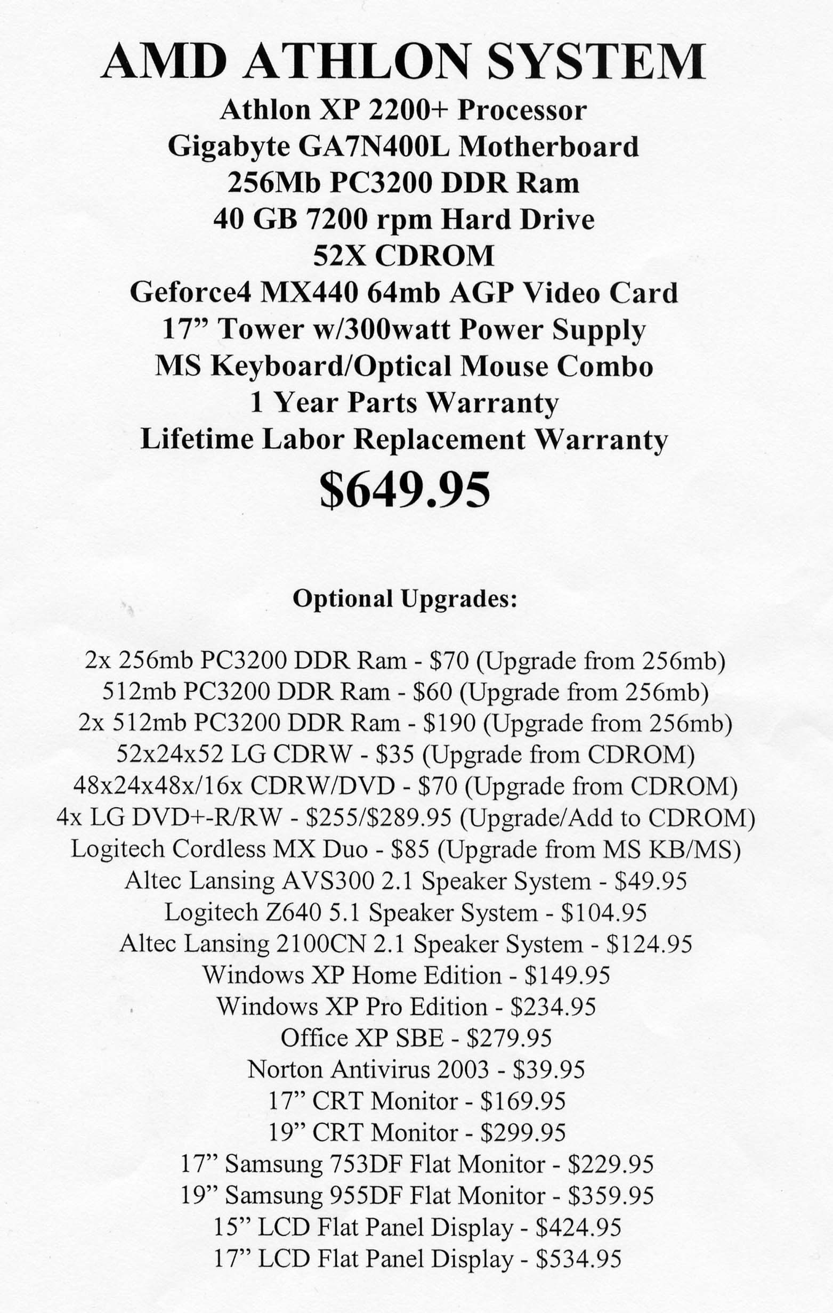

- Take a look at the three specification sheets (provided by the instructor). Which computer do you think was the most expensive? The least?

Mouse Terminology

Click Click once with left mouse button.

Double-click Click twice (quickly) with left mouse button.

Right-click Click once with right mouse button.

Press and Drag Hold down left mouse button and drag mouse.
Windows

Windows is the Operating System. It is the program used to communicate with the computer. An operating system is an essential piece of software that enables you to communicate with the computer. In other words, the operating system translates what you type in on the keyboard to a number-based language that the computer can understand.

When you purchase a computer, an operating system comes automatically installed on your computer’s hard drive. The most recent version of Windows (launched in 2009) is “Windows 7”. Earlier versions of Windows are still widely in use and include Windows XP (released in 2001) and Windows Vista (released in 2005).

Windows is designed to be intuitive. The example below (Windows XP) shows the Windows Desktop. The Desktop is a digital analogy of a real world desktop. The Desktop is where we go to do our work. Windows provides the tools to keep our work organized. Windows allows us to customize our work environment: change the colors, set a screen saver (so our monitor doesn’t burn out), and more.

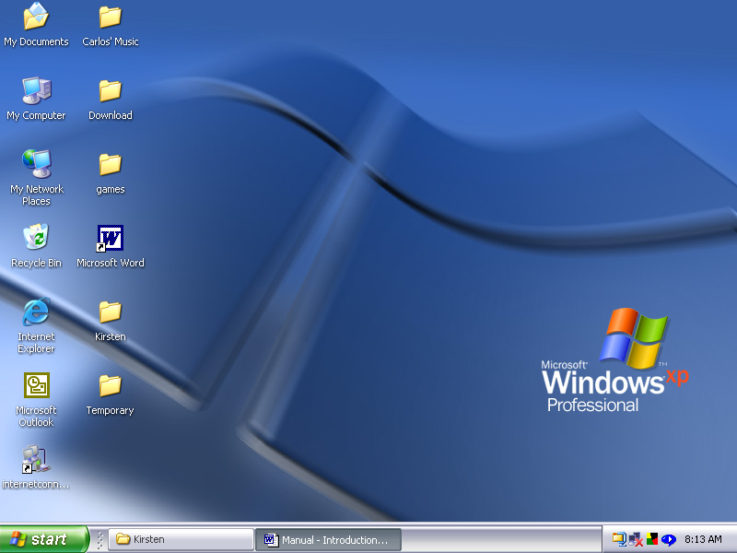

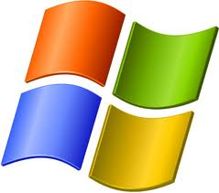
In Vista and Windows 7, this button is not labeled as “Start”, but is just represented by the Windows logo
Icons
These are pictorial representations of files and folders on the desktop or in individual folders.

Typical icons on a desktop:

My Documents Where work files get stored (by default).

My Computer Displays contents of your computer such as the files on the hard drive. Also, allows you to set the colors of you screen display and control the speed of your mouse.

Recycle Bin Temporary storage location for deleted files.

Start Button Enables you to run applications that are installed on the computer (i.e. word-processing program). Also provides access to on-line help, and enables you to locate files on your computer.

Taskbar Displays an icon of all programs and windows currently open.

Elements of a Window

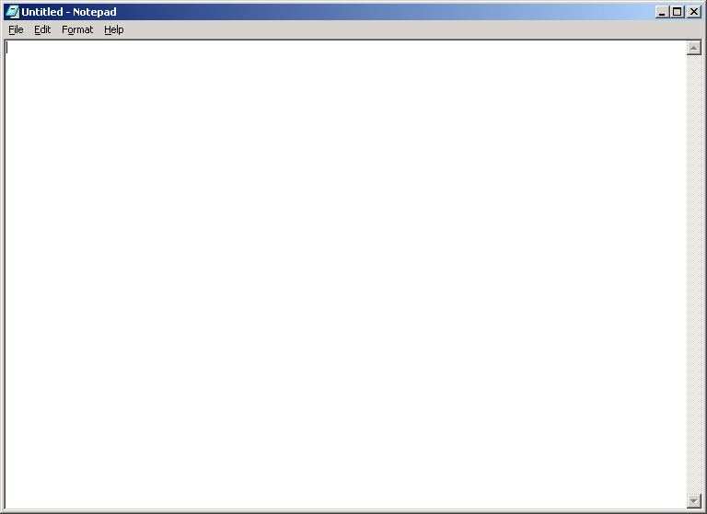
Minimize, Restore, Maximize buttons
Menu Bar Title Bar
Scroll Bar will appear when needed along the side or bottom of window. Allow you to manipulate contents of window horizontally and vertically.
Exercise

- Open up Recycle bin icon.

- Minimize the Recycle Bin to the Task Bar

- Open up the Recycle Bin from the Task Bar. Practice resizing the open window.
- Place your mouse pointer on any edge of the open window. Press and drag the mouse pulling the window in the direction of the mouse movement.

- Try moving the window around the screen.
- Place you mouse point on the Title Bar of the open window. Press and drag the mouse moving the window in the direction of the mouse movement.

- What is the difference between maximizing and minimizing a window? How do you resize a window?

Why Resize Windows Anyways?
You cannot resize or move a window if it is fully maximized. For most practical purposes understanding how to maximize or minimize a window is enough, you do not need to move or resize windows on a regular basis. However, there are incidences when a window opens inside another window. You may need to move or resize one window to unblock an important part of the other window.

- What are the various icon on your desktop used for?
- My Computer
- Recycle Bin
- Internet Explorer
- My Documents

- Click on the Start Button on the Taskbar. What are following Menu items:
- Documents
- Settings
- Search
- Help
- Run
My Computer

The My Computer is one place you can go to look at gives the computer’s hardware specifications, install and remove software, change settings and manage files. When you open the My Computer icon on your Desktop or after left clicking on the START button, you generally will see a Window similar to the one displayed below. In Microsoft Vista and Windows 7 it is labeled as “Computer” (not necessarily My Computer)

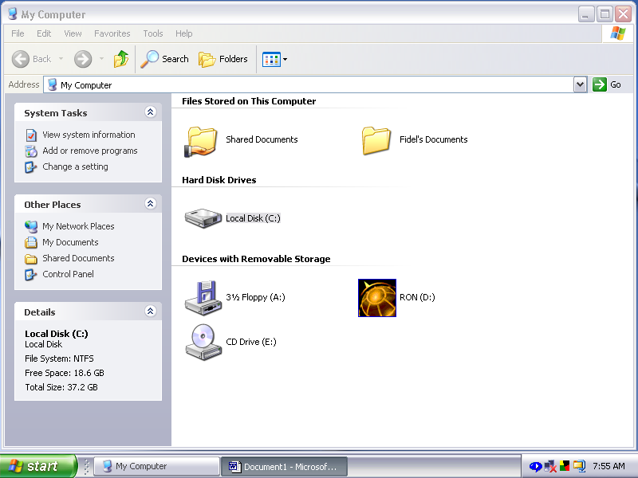

Explore the Views
There are different ways to view the above window.

- Click View menu.
- Click Details. What does the Window look like?
- Click View menu.
- Click List. What does the Window look like?

In addition to switching views above, the window has toolbars that can be turned on and off. The Toolbars command is also located under the View menu. The toolbars you want on are the Standard toolbar and the Address toolbar.

Finally, there is a Folders button on the Standard toolbar. This is very useful to switch the Window to Explorer view. Take a look at what happens when you click on this button (it works like a toggle on/off switch). The Explorer view will be discussed in more detail in the File Management section of this course.
View Disk Properties

Windows XP shows the disk properties when you click on the disk. The properties show along the left hand side of the My Computer window. For older versions of Windows right-click disk letter.

Disk Properties

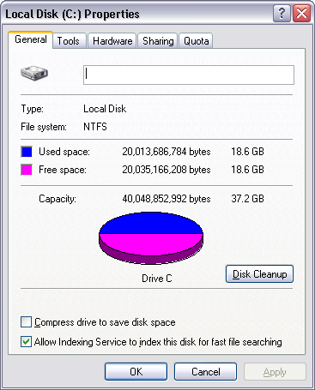

A note on drive letters

Drive C is usually the hard drive
Drive A is the floppy (3 ½ inch) drive
Drive D is usually the CD-ROM drive (or CDRW drive)
Drives E and other letters are usually network locations, USB flash drives, digital cameras or other storage devices connected to the computer.

Depending on the computer system and the setup of the system you may have more or less drives. For example, you can have two hard drives (say one drive was running out of space and you added another one). The first hard drive is Drive C. The second hard drive is Drive D. The CD ROM becomes Drive E. If you add a CD Burner (CDRW) it becomes Drive F. The drive assignments are automatically made by the computer
Control Panel
The Control Panel is full of specialized tools that are used to change the way Windows looks and behaves. For example, use Mouse to replace standard mouse pointers with animated icons that move on your screen. If you are left-handed, you can use Mouse to switch the mouse buttons so that the button on the right performs the primary functions of selecting and dragging. Sounds and Audio Devices to replace standard system sounds with sounds you choose. Other tools help you set up Windows so that your computer is easier to use
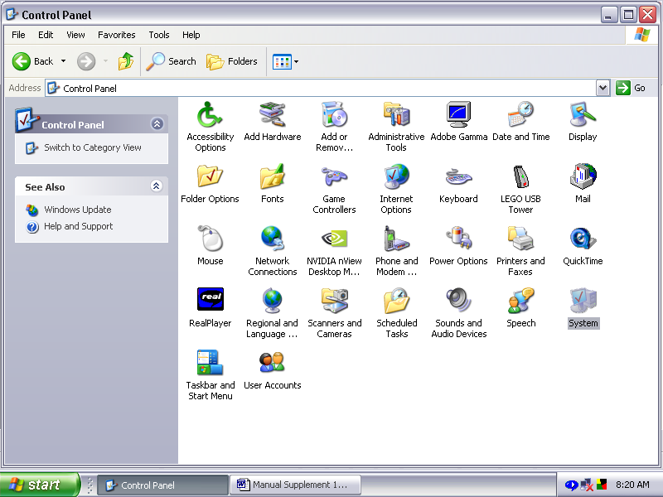
Switch from Category View to Classic View.

Opening the Control Panel

When you open the Control Panel it will most likely be in Category View, as this is the default view in Windows XP. To switch to the Classic View, displayed above, look for the option in the left hand panel of the window.

It is important to note that there is more than one way to do almost everything in Windows. You can access the Control Panel from within the My Computer window. Alternatively, click the Start Menu, click Settings and click Control Panel. To add to the confusion, many of the Control Panel tools can be accessed independently. For example, the Display properties can be opened directly from the Desktop. Right-click the Desktop, click Properties. Your instructor will show you one way of doing things and no doubt you will soon start finding things our on your own.
Windows Accessories

The Accessories are the bells and windows of the operating system.

- Click Start menu, click Programs, click Accessories.
- A pop out menu will appear with a list of Accessories available.
- Hover mouse over menu item and a pop-out description of item will appear.

Accessibility Magnifier, Narrator, On-screen Keyboard

Communications Fax, HyperTerminal, Net meeting, Remote Desktop Connection.

Entertainment CD Player, Volume Control, Media Player

Games Solitaire, Minesweeper, Pinball, FreeCell

System Tools Disk management tools such as Backup, Defragmenter

Address Book Address information stored in system. Used with Outlook Express (the e-mail software that comes with Windows)

Calculator Digital Calculator

Command Prompt Activiates the Command (DOS) prompt

Imaging Displays and edits existing image files

Notepad Creates and edits text files (no formatting)

Paint Creates and edits drawings and displays and edits scanned photos.

Synchronize Updates the network copy of materials that were edited offline.

Explorer Displays the files and folders on your computer.

WordPad Creates and edits documents with text formatting.

Organizing your work

If everyday you came home and threw your days stuff onto the kitchen table, imagine what it would look like by the end of the week. You would have to go through countless items before finding exactly what you are looking for. Well it is the same with the computer. When working on a computer, if you don’t put things where they belong, it is not long before work becomes difficult to find. The computer uses a hierarchical system of file organization that begins at the ROOT and branches off from there. The next page gives an example of how folders might be organized on a computer. While studying the System of Folders diagram on the next page may be interesting, it is not essential to understand the information at this point. For most beginning computer users, all the necessary file management can be done right on the Desktop.

The Desktop

The Desktop is a special folder with unique characteristics that is designed to appear in the forground at all times. In reality, the Desktop is only a façade covering the nuts and bolts of file activities underneathSystem of Folders

When you save a file you need to be clear on where the file is going. For example, you can save files right onto the Desktop or choose to save a file into a separate folder. If you are using Microsoft Office, files automatically get saved in the My Documents folder that is located immediately off of the Root of Drive C

Sample of Filing System on Harddrive

Root Directory

C:\
 |  |  |  |  |  |  |  | PATH:
 |  | Documents and Settings
 |  |  | Default Settings |  |  |  |  | c:\Documents and Settings\Desktop
 |  |  |  |  | Desktop
 |  | Program Files |  |  |  |  |  | c:\Program Files
 |  |  |  |  |  |  |  | Programs you install go here.
 |  | Windows
 |  |  | Addins
 |  |  | Fonts
 |  |  | Others… |  |  |  |  | c:\Windows

The Windows Explorer

There are many ways to turn on the Windows Explorer:
- Open up My Computer (or “Computer” in Vista or Windows 7) and turn on the Folders button.
- Or Right-click Start Button, click Explore.
- Or Double-click Explorer button on Desktop (if available).

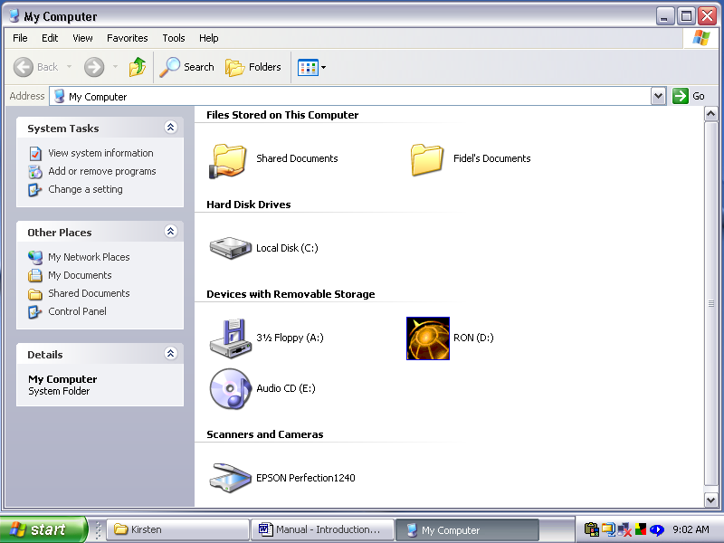

Display in Windows XP
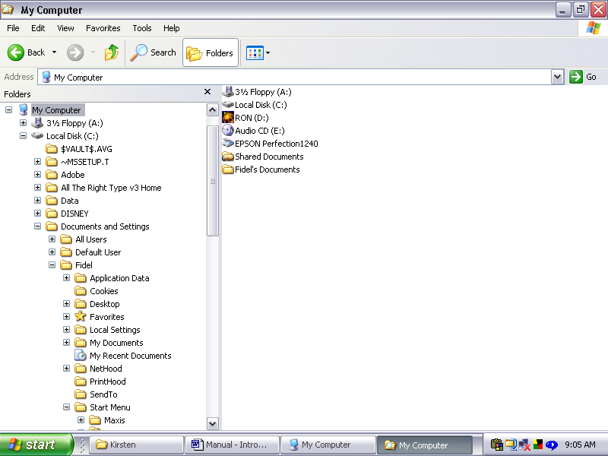
File Management Cheat Sheet

Create a Folder

- Right click the Desktop (or open Window). Click New
- Click Folder. A yellow folder will appear on the desktop.
- Type in a name for the folder. Press the Enter key to accept the name.

Rename a Folder

- Right click the folder. Click rename.
- Type in a new name. Press the Enter key to accept the name.

Selecting Files

Single File click on file
Non sequential range Hold down CTRL key and click on any number of files
Sequential range Click on first file in range, hold down shift key and click on last file in range. All files between the two clicks will be selected.

Copying files – Drag and Drop

Drag file with right mouse button depressed. Release mouse in new location. A message will prompt to move or copy the file to the new location.

Copying files – Edit Menu

The Edit menu is available in all applications so it remains the one consistent way to copy and move files (and other items) from one location to another. However, it is confusing to learn at first as there are so many steps.

- Click to select the file you want to move or copy.
- Click Edit menu.
- Click Copy command.
- Click in new location.
- Click Edit menu.
- Click Paste command.

Send To

- Right click file
- Click Send To… command
- Select Drive A

Exercise

- Open up WordPad.
- On the Taskbar, click the START button.
- A menu will pop up. Click All Programs. Click Accessories. Click WordPad.

- Create a document by typing in a few words.

- Save the file.. Use the filename TEST ONE.

- Minimize WordPad.

- Open up Paint.
- On the Taskbar, click the START button.
- A menu will pop up. Click Programs. Click Accessories. Click Paint.

- Using the drawing tools provided (some of these tools will be discussed in class, however don’t be afraid to explore the tools on your own) create a quick picture.

- Save the file. Use the filename TEST TWO.

- Minimize Paint to the Taskbar.

Difference between SAVE and SAVE AS…

The first time you save a file, there is no difference between the Save and Save As command. Both commands will prompt you with a dialogue box requesting information about the file. You must specify the name and location of the file to be saved. The second and subsequent times a file is saved there is a BIG difference between the two commands:

- Using the Save command will save the file again using the same name, simply updating the file with changes made since the previous save.

- Using the Save As command will prompt you with the dialogue box asking you to specify the name and location of the file. If you don’t want to change the name or location of the file, just click the OK button. The file will be updated. However, there are times when you might want to change the name and/or location of the file. For example, you can use the Save As to save the file onto a floppy disk, or save two versions of the same file (one to Anne and one to Joe). If you are not sure of the difference between the two types of saves, always use the Save As command.

Exercise

- Create a folder on the desktop
- Right-click on the Desktop
- In the pop-up menu, click New
- Click Folder (a yellow file folder icon will appear on the desktop)
- Type EXERCISE in the blank title area located beneath the folder.

- Drag the Test One and Test Two files into the Exercise folder.

- Open up Exercise folder to verify that the file is in the folder.
- Double-click the Exercise folder

- Delete the Test One file in the Exercise folder.
- Click the file to select the file. Press the delete key on the keyboard. You will be prompted with a message “Are you sure you want to send TEST1.DOC to the Recycle Bin”. Click OK to delete the file.

Recycle Bin

Windows uses the Recycle Bin to store the deleted files. If you accidentally delete a file you may be able to retrieve the file from the Recycle Bin. Try it. Open the Recycle Bin icon. Right click the file you just deleted. Click Restore. The Test One file will reappear in the Exercise folder.

Depending on how your computer is set up, restoring files from the Recycle Bin is not always this easy. Never delete a file unless you are sure of the files contents (open up the file and check it before you delete it).

Shortcuts

Windows uses a very complex system of folders to organize program and work files. Windows uses shortcuts to minimize clicking to find a file or program.

Create a shortcut to Drive A.

- Double-click My Computer icon on Desktop to open up the My Computer Window.
- Right-click the Drive A icon
- Click Shortcut from pop-out menu.
A message will appear stating “Windows cannot create a shortcut here. Would you like to create a shortcut on the Desktop instead?”
- Click OK. A new icon will appear on the Desktop that looks very much like the Drive A icon, except it has a curved arrow in the bottom right hand corner of the icon.
- Now you can access Drive A straight from the Desktop

Program Shortcuts

You can easily create a shortcut to any of the programs listed on the Start menu. Find the program listed on the Start menu. Right click the program and click Create Shortcut. A shortcut icon will appear on the Desktop.

Exercise

- Create a shortcut to Notepad on the Desktop.

- Try some other shortcuts. What happens if the program you want does not appear on the Start Menu?

Searching for Files

Click Start Button.
Click Search.
In Windows XP, make sure you maximize the Search Window to see all the Search options.

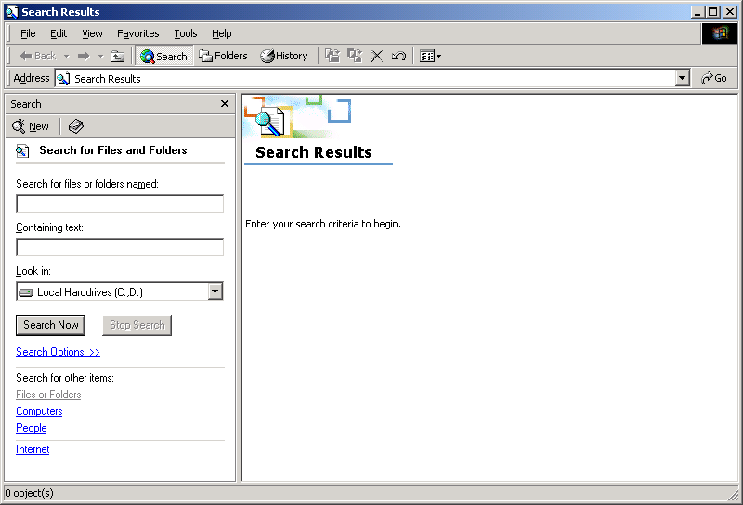

In Windows 7 or Vista, you can search directly from the Start Menu!

Some Common File Types

.bmp bitmap (graphic) file

.doc document file created in Microsoft Word for Windows

.exe program execution file

.wmf windows metafile (clipart that comes with MS Word is this type of file)

.xls spreadsheet file created in Microsoft Excel

Common Internet File Types

.gif Graphic Interchange Format, Internet graphic file

.html Hypertext Markup Language (Internet)

.jpg Internet graphic file (photographs)

.mpeg Standard movie format for the Internet

.mov Quicktime movie file (Apple/Macintosh native movie format)

.pdf Adobe Acrobat Portable Document Format

.tif Very large high quality image format

.txt text file (there are a lot of .txt files stored in your windows folder c:\windows, double-click on the file to read the information. The text files often include important and/or interesting information).

.wav sound file

.zip compress file, compress using the PKZIP compression utility

Remember we are not talking Macintosh systems here.

