Additional Topic Pages:

- Hardware vs. Software
- How to Buy a Computer
- Computer viruses
- Computer Worms
- Phishing
- Help! Something's wrong with my computer!
- Computer Cleanup
- What is the Internet
- What is Email?
- Topics in Internet Searching
- Interesting/Important/”Trendy” Websites

Hardware vs. Software
Software is a general term used to describe a collection of computer programs, procedures, and documentation that perform some task on a computer system. Practical computer systems divide software systems into three major classes: system software, programming software, and application software, although the distinction is arbitrary and often blurred. Software is an ordered sequence of instructions for changing the state of the computer hardware in a particular sequence. It is usually written in high-level programming languages that are easier and more efficient for humans to use (closer to natural language) than machine language. High-level languages are compiled or interpreted into machine language object code. Software may also be written in an assembly language, essentially, a mnemonic representation of a machine language using a natural language alphabet.

Hardware is best described as a device that is physically connected to the computer or something that can be physically touched. A CD-ROM, monitor, printer, and video card are all examples of computer hardware. Without any hardware your computer would not exist and software would have nothing to run on. It is the physical part of a computer, including the digital circuitry, as distinguished from the computer software that executes within the hardware.

Type
Hardware is a physical device something that you’re able to touch and see. For example, the computer monitor you’re viewing this text on or the mouse you’re using to navigate is considered computer hardware. Software is a program that enables a computer to perform a specific task, as opposed to the physical components of the system (hardware).

Function
Software performs the specific task that requires completion by giving the ordered set of instructions to complete it.
Hardware serves as the delivery system for software solutions.

Examples
Examples of Hardware types include a CD-ROM, monitor, printer, video card etc. While some examples of software can be Internet Explorer, Microsoft Word etc.

Interdependency
Hardware cannot function till software is loaded and software is installed in hardware to set the programs in action.

Firewalls
Firewalls can be both for Hardware and Software. The most popular firewall choice is a software firewall which are installed on the computer (like any software) and can be customized and allow control over its function and protection features. Hardware firewalls are typically found in broadband routers.

Changes
The hardware of a computer is infrequently changed, in comparison with software and data, which are “soft” in the sense that they are readily created, modified, or erased on the computer. With technological changes, software changes take place faster than hardware changes.
Hardware and software work together in digital devices and systems to provide computerized functionality. Hardware includes the physical components, such as the Motherboard, chips, memory, and hard drives, while software includes the programs that run on the hardware. Ergo, a computer is hardware, while an operating system such as Microsoft XP is the software that makes the hardware functional. Though hardware and software are most often associated with computers, software also runs on other hardware, such as cellular phones, personal digital assistants(PDAs), Global Positioning Satellite (GPS) units, medical equipment, and air traffic control system. Without any type of software the computer would be useless. For example, one wouldn’t be able to interact with the computer without a software Operating System.

How to Buy a Computer
By eHow Contributing Writer

Buying a computer means investigating many features: RAM (random-access memory), processor speed, graphics capability, hard disk space and so on. Here's how to start.

Things You'll Need To Consider:

- CD-ROM Drives
- CD-RW Burners
- CPU (computer Processors)
- DVD-ROM Drive
- RAM
- Zip Drives
- Computer Keyboards
- Computer Mice
- Computer Monitors
- Computer Speakers
- Floppy Disk Drive
- Hard Disks
- Modems
- Printers
- Sound Cards
- Video Cards
- Credit Cards And Loans
- Computers
- Microsoft Office
- Microsoft Windows
- Anti-virus Software

Step 1: Choose a specialty store, consumer electronics store, retail chain, limited service discount chain, local computer builder or mail-order/Internet vendor, based on your hardware and service needs.
Step 2: Buy when you need to buy. No matter how long you wait for the best deal, the same configuration will cost less in six months.
Step 3: Decide which features you'll need based on what you're going to do with the computer. For example, if you're going to be creating graphics, sound and video, you'll want plenty of RAM. If you're going to be doing heavy computational tasks (searching large databases, watching video), you'll want a super processor.
Step 4: Decide if you want a laptop, which you can carry around with you, or a desktop model.
Step 5: Choose a computer brand based on quality, price and technical support.
Step 6: Based on your likely needs, determined earlier, figure out the core configuration you need, including processor and speed, amount of RAM and hard drive size.
Step 7: Determine additional drives you need: CD-ROM, DVD-ROM, CD recorder, Zip.
Step 8: Select peripherals and additional hardware such as modems, sound cards, video cards and speakers.
Step 9: Decide how many extra internal card slots and disk-drive bays you'll need in order to allow room for future expansion.
Step 10: Determine what pre-installed software you want or need. Get at least an operating system, such as Windows, an anti-virus program, and programs for word processing, spreadsheets, databases and keeping your checkbook.
Step 11: Choose the length of warranty or service coverage appropriate to your needs.

Tips & Warnings
- Keep abreast of the latest technology by reading the new-product reviews in magazines and on the Web. Find out what hardware and soft-ware are included with the models you're considering, and use that as a basis for comparing prices. Ask 'What's the catch?' if a price seems too low.
- Understand that RAM is where your computer temporarily stores data to be processed. Although more RAM is better, you don't need much if you restrict your computer use to simple tasks (word processing, check balancing).
- Games, however, can require lots of RAM; graphics and sound are other space hogs.
- Today's processors are usually fast enough for all but the most demanding applications, such as streaming video.

Computer Viruses? What really are they?

One might think of a computer virus as a tiny computer program designed to perform mischief. Most computer users have heard about computer viruses. A computer virus is the result of a destructive program that someone has written and placed inside a computer program, which unsuspecting people then place in their computer system.
Some viruses can erase all the information from the place where it's stored on the computer's hard disk. But each virus is different. Some display strange messages on your computer screen; others make small changes in your computer programs.
Where do these viruses come from? They certainly don't float around in the air like some human viruses. Instead, like any other computer program, a human must create them.
Why do people create them? It's hard to say. Some people create these programs out of meanness to get even, while others create them just as a challenge. Why do you thing people create these very destructive programs? How does your computer get a virus? Almost exactly the way humans do. The computer gets exposed to one. Well, it’s not quiet that easy…
Many people get contaminated computer programs by trading programs with other people. Others get contaminated computer programs through the use of modems, which allow computers to communicate over telephone lines (i.e. The Internet)
Most of the time, programs that arrive by modem or a trade are perfectly safe to use. However, you do stand a chance of getting a program that has been tampered with. Here a computer program virus is hiding inside the normal program. Many computer programs that are traded were copied illegally.
When this program enters your computer through your input device, it hides in your computer's memory and starts to duplicate itself like a disease. When you save your data, you also save the virus. Slowly but surely, the virus crowds out your data and causes major system problems.
The virus can't affect the computer's ROM (Read Only Memory), but it can affect RAM (Random Access Memory) and your computer disks. When your shut off your computer a virus that has been picked up will be lost, just like any other memory that is held in RAM.
If the virus is on your disk or hard drive, it will return to the computer when you use the program again. If you switch from one program to another without shutting down the machine, the virus will attach itself to the new program. In this way, it can slowly infect all your programs before you know that it exists. Today millions of dollars are being spent to rid and protect computer systems from these virus programs.
Commercial and shareware programs have been created with the sole purpose of detecting and fixing suspect programs that might be viruses infected. These detection programs should be ran when any disk is put into your disk drive or every time your computer is first started up each day to scan the computer's hard drive.

Computer worms

From Wikipedia, the free encyclopedia
A computer worm is a self-replicating computer program. It uses a network to send copies of itself to other nodes (computers on the network) and it may do so without any user intervention. This is due to the poor security the computers infected have. Unlike a virus, it does not need to attach itself to an existing program. Worms almost always cause at least some harm to the network, if only by consuming bandwidth, whereas viruses almost always corrupt or modify files on a targeted computer.

Payloads
Many worms that have been created are only designed to spread, and don't attempt to alter the systems they pass through. However, as the Morris worm and Mydoom showed, the network traffic and other unintended effects can often cause major disruption. A "payload" is code designed to do more than spread the worm - it might delete files on a host system (e.g., the ExploreZip worm), encrypt files in a cryptoviral extortion attack, or send documents via e-mail. A very common payload for worms is to install a backdoor in the infected computer to allow the creation of a "zombie" computer under control of the worm author - Sobig and Mydoom are examples which created zombies. Networks of such machines are often referred to as botnets and are very commonly used by spam senders for sending junk email or to cloak their website's address.^{[1]} Spammers are therefore thought to be a source of funding for the creation of such worms,^{[2][3]} and the worm writers have been caught selling lists of IP addresses of infected machines.^{[4]} Others try to blackmail companies with threatened DoS attacks.^{[5]}
Backdoors can be exploited by other malware, including worms. Examples include Doomjuice, which spreads better using the backdoor opened by Mydoom, and at least one instance of malware taking advantage of the rootkit and backdoor installed by the Sony/BMG DRM software utilized by millions of music CDs prior to late 2005

Phishing (What is it?)
Phishing is a type of deception designed to steal your valuable personal data, such as credit card numbers, passwords, account data, or other information. Con artists might send millions of fraudulent e-mail messages that appear to come from Web sites you trust, like your bank or credit card company, and request that you provide personal information.

What does a phishing scam look like?
As scam artists become more sophisticated, so do their phishing e-mail messages and pop-up windows. They often include official-looking logos from real organizations and other identifying information taken directly from legitimate Web sites.
The following is an example of what a phishing scam e-mail message might look like.
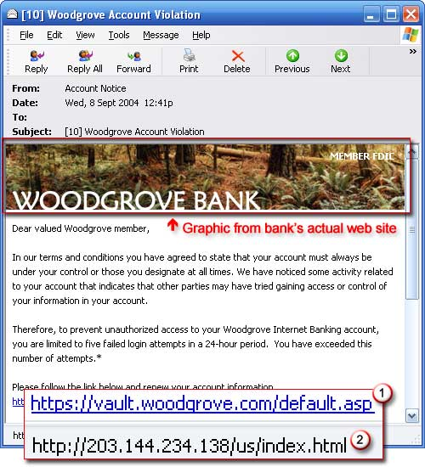

Example of a phishing e-mail message, including a deceptive URL address linking to a scam Web site
To make these phishing e-mail messages look even more legitimate, the scam artists may place a link in them that appears to go to the legitimate Web site (1), but it actually takes you to a phony scam site (2) or possibly a pop-up window that looks exactly like the official site. These copycat sites are also called "spoofed" Web sites. Once you're at one of these spoofed sites, you might unwittingly send personal information to the con artists.

How to tell if an e-mail message is fraudulent
Here are a few phrases to look for if you think an e-mail message is a phishing scam.
"Verify your account."
Businesses should not ask you to send passwords, login names, Social Security numbers, or other personal information through e-mail.
"If you don't respond within 48 hours, your account will be closed."
These messages convey a sense of urgency so that you'll respond immediately without thinking. Phishing e-mail might even claim that your response is required because your account might have been compromised.
"Dear Valued Customer."
Phishing e-mail messages are usually sent out in bulk and often do not contain your first or last name.
"Click the link below to gain access to your account."
HTML-formatted messages can contain links or forms that you can fill out just as you'd fill out a form on a Web site. The links that you are urged to click may contain all or part of a real company's name and are usually "masked," meaning that the link you see does not take you to that address but somewhere different, usually a phony Web site.
Notice in the following example that resting the mouse pointer on the link reveals the real Web address, as shown in the box with the yellow background. The string of cryptic numbers looks nothing like the company's Web address, which is a suspicious sign.
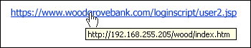
Example of masked URL address
Con artists also use Uniform Resource Locators (URLs) that resemble the name of a well-known company but are slightly altered by adding, omitting, or transposing letters. For example, the URL "www.microsoft.com" could appear instead as www.micosoft.com

Help! Something's wrong with my computer!

Diagnosing the problem
Have you noticed your new PC running slower and slower, with numerous strange error messages? Do you experience many unwanted "pop-up" advertisements when you surf the web? Is your computer freezing and rebooting itself?
These scenarios are typical indicators of the following three classes of computer problems:
Viruses
Adware and Spyware
Hardware Problems
If something is wrong with your computer, the first step you should take is to gather information about the problem. Next, use the table below to determine what might be causing the problem. Then, refer to the information in the appropriate section below for advice.
Class of Problem | Typical Indicators
Viruses | - Windows freezes  - computer runs slowly  - error messages appear  - programs crash  - hard drive light is on when you are not using the computer
Adware and Spyware | - pop-up advertisements  - new icons in lower right corner of screen, by the clock  - Kazaa, eAcceleration, Internet Optimizer, or Comet Cursor installed  - Windows takes a long time to load
Hardware Problems | - computer will not turn on or start up  - computer randomly reboots itself  - display switches to low resolution  - computer makes whining, buzzing, or squealing noises  - errors detected on the hard drive

Note: If you own an Apple computer, it is unlikely that your computer problem is due to viruses, adware, or spyware.

Viruses
A computer virus is a self-replicating program that copies itself and that can infect other programs. Viruses gain access to your computer from a number of sources, including email, file sharing, and downloaded files. There are also a number of common virus hoaxes circulating via email. To prevent virus infections, your computer needs effective and up-to-date antivirus software.

Adware and Spyware
Free file-sharing programs such as LimeWire, Kazaa, and iMesh, or downloadable games such as Snood are advertising supported. However, the advertising components often cause your computer to run slowly, crash more often, and can even break your Internet connection. This advertising software is referred to as adware or spyware and not only causes pop-up ads to appear when you surf the web, but also monitors how you use your computer and what websites you visit.
Spyware, as defined by Counterexploitation (cexx.org), typically describes software whose purpose is to collect demographic and usage information from your computer, usually for advertising purposes. The term is also used to describe software that sneaks onto your computer or performs other activities hidden from you.
Typical indicators of spyware are your computer running slowly, advertising pop-ups on the Internet, and new icons in the lower right corner of the screen. To rid your computer of adware and spyware, you can scan your system with Spybot Search & Destroy or Lavasoft's Ad-aware. Be careful to avoid fake spyware removers.

Computer Cleanup
There are simple computer maintenance procedures that anyone can do on their own. They don’t require tons of skill and when done regularly will help keep your computer from becoming fat and sassy.

Empty Your Recycle Bin
If you kept trash around in your house for weeks, months, or years it would begin to stink. Computer trash doesn’t stink but it does use up space that your computer might need for better things. Do this every few weeks.
- Locate the Recycle Bin icon on your desktop and open it. (Double click)
- Scan the list of files in the recycle bin to see if you really do want to get rid of everything there,
- If so, click on the Empty the Recycle Bin link. When it asks you if you’re sure, tell it yes.
- If there’s something you want to keep, select that item and then select the restore the item link. You can restore everything by selecting the Restore All Items link when nothing is selected. (Remember to select an item you click on it once.)
- After you’ve restored anything you want to restore, do step 3 to empty the recycle bin.
- Close your recycle bin. Trash has been taken to the dump and is now gone for good. You cannot restore it.

Temporary Internet Files
As you browse in Internet Explorer or Netscape, your computer saves copies of the files used on the sites you visit. It keeps these files handy so that if you return to that site a little later, it can put that site up more quickly because the necessary files are already on your computer. It’s faster to get them from your computer than from the website. If you go to lots of places, you can have lots and lots of these temporary Internet files building up in a place called your cache. Now a cache of money is a good thing, but a cache of temporary files may not be. Too many files in your cache can cause your computer to slow down and can make your browser slow to close down, too. It’s easy to empty your cache. Do this every few weeks if you do a lot of browsing or every couple of months if you don’t.
Internet Explorer
Open your Internet Explorer Browser and from the Tools pull down menu at the top of your browser select Internet Options.
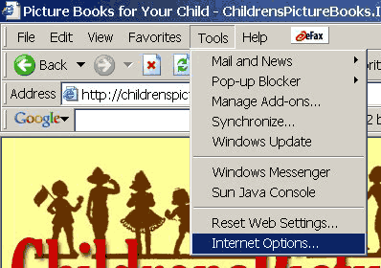
In the center of the Internet Options screen you’ll find Temporary Internet Files. Select the Delete Files button.
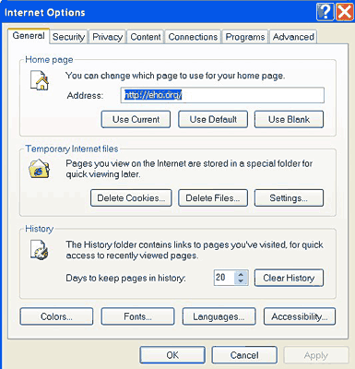
When the pop up asks you if you want to delete all offline content, check that box and then select OK.
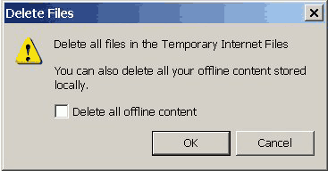
To adjust the amount of space you allow for temporary internet files, select the Settings button. Change the amount of disk space to use to between 2 and 5 MB or larger if you do a lot of browsing.
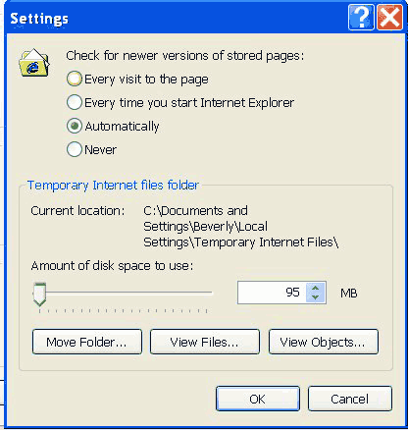

Netscape (Firefox is similar)
Open your Netscape browser and from the Edit pull down menu at the top of your browser select Preferences.
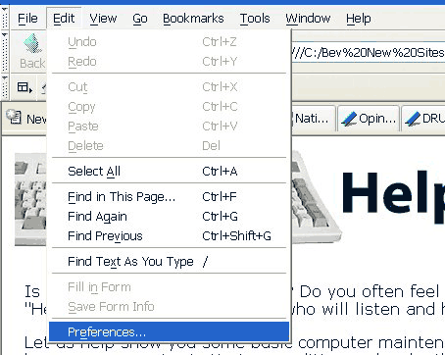
On the Preferences screen, click the Plus sign beside Advanced to open that topic.
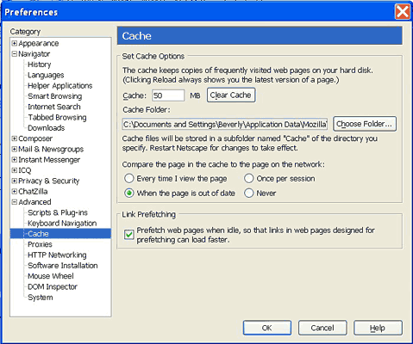
Select Cache.
To clear your cache, select the Clear Cache button
You can also keep your cache from growing too large by limiting its size to between 2 and 5 MB or larger if you do a lot of browsing. The spot to do that is right next to the Clear Cache button. Enter the number you prefer.

What About Cookies?
Yes, you can clear your cookies, but doing so will eliminate all the cookies set that you may have come to rely on. For example, some cookies facilitate automatic password entry on certain sites. Rather than deleting all your cookies, we suggest you run software that will find the “bad” cookies and let it eliminate just those.

What is the Internet?
The Internet, in simplest terms, is the large group of millions of computers around the world that are all connected to one another. These computers are connected by phone lines, fiber optic lines, coaxial cable, satellites, and wireless connections.
When you log on to the Internet you are given access to many of the other computers that are connected around the world.
Some common ways of connecting to the Internet include:
- Internet service provider (ISP) by modem
- Internet ready cable
- digital subscriber line (DSL)
- simply turning on your computer which is on a network at work or school connected to the Internet
Today you can even get a wireless connection to the Internet with a handheld PC or notebook computer.
Once you are connected to the Internet you are able to do many things. You can send and receive e-mail. You can chat with text or voice. You can browse the World Wide Web. And you can perform countless other tasks with the appropriate software.
The Internet works a lot like a postal or parcel delivery system, except it is much, much faster. Say, for example, you are in California and want to send an e-mail to a friend in London. After you press the send button, your e-mail goes to your mail server. (Your mail server isn't usually part of your computer, but rather part of your internet service provider's computer network, so you can disconnect as soon as you press the send button and it won't interrupt delivery.) The mail server will attempt to contact your friend's mail server in London. But chances are your mail server doesn't have a direct line connecting it to your friend's mail server in London. Your mail server may have to "talk" to a computer in Chicago, which then takes to a computer in Washington, D.C., which contacts the London server via satellite. Or the Washington, D.C. computer might contact London via an undersea cable.
If the satellite or undersea cable appeared to be busy with other Internet data, your mail server may try sending west through Australia or Japan. In theory, the e-mail, although probably just a few paragraphs may possibly be broken into two or more parts and half of it would be sent east and half west. All the pieces would be reconstructed in London in one piece for your friend to read next time they log on.
The Internet is very dynamic. Routers and other computer server hardware try to find the best lines between servers so you get the best possible service. All of these connections are transparent to you, the Internet User. All of these connections look just like a direct connection to you. It makes using the Internet a lot easier.
CAUTION: It is important that you use a secure server when transferring personal information like credit card numbers over the Internet because any stop along the way (again, in theory) could log your credit card number. When you use a secure server, the number is encrypted (coded) and looks like gibberish to every computer except the one you are sending the number to. Look for a "secure server" option before entering your credit card number online.

What is email?

E-mail is the exchange of text messages and files, over a network or the internet, between computers. To use e-mail, you need an e-mail account and a mail program.

When you subscribe to an Internet account from an Internet Service Provider, you automatically get an e-mail account. If your company offers e-mail, you will probably receive an e-mail account from your network administrator.

You can think of an e-mail account as a separate area on your provider’s computer used to store incoming and outgoing messages temporarily. Your provider uses a mail server to send and receive your messages.

Your e-mail account is identified by your e-mail address, which others use to send messages to you. The first part of the address is your user name, which you can generally choose yourself. The part of the address after the @ sign represents the mail server that your provider uses.

A mail program enables you to work with your e-mail messages on your computer. Just as Windows Vista comes with Internet Explorer, it also offers a mail program, called Windows Mail.

Internet Searching

How can you tell if an Internet site is reliable?

REMEMBER: Anyone can post information on the Internet!

Make sure the information you are using comes from a person or organization that can be trusted.

One simple way to tell if a site is reliable is to look at who runs the site. Usually, looking at the first section of a web address will tell you where it came from. If it came from a museum, university, or some other place you’ve heard of, chances are that it can be trusted.

The following slide provides a checklist you can use to decide whether a website is reliable. If the site contains several characteristics in the “Questionable” column, you probably shouldn’t use it!

“Smarter” searching on the Internet

Most Internet search engines also allow you to use a set of words or symbols to narrow your search.

AND – use this word when you want to find two words together. For example “computer virus AND xp”

OR – use this when you can accept a couple of words. For example, “computer virus OR internet worm”

- (Minus sign) – use this symbol when you want to exclude a word. For example, “computer virus -recent”

“Quotations” – use quotation marks when you are searching for an exact phrase. For example, if you were searching for a book title, you could type “The I Love You virus” in quotations and the search engine will look for that exact phrase.

Interesting/Important/”Trendy” Websites

Google www.google.com
From Wikipedia, the free encyclopedia

Google Inc. is a multinational public cloud computing and Internet search technologies corporation. Google hosts and develops a number of Internet-based services and products, and generates profit primarily from advertising through its AdWords program. The company was founded by Larry Page and Sergey Brin while the two were attending Stanford University as Ph.D. candidates. It was first incorporated as a privately held company on September 4, 1998, with its initial public offering to follow on August 19, 2004. The company's stated mission from the outset was "to organize the world's information and make it universally accessible and useful", and the company's unofficial slogan – coined by Google engineer Paul Buchheit – is Don't be evil.
Facebook www.facebook.com
From Wikipedia, the free encyclopedia

Facebook is a social networking website that is operated and privately owned by Facebook, Inc.^{[1]} Since September 2006, anyone over the age of 13 with a valid e-mail address (and not residing in one of the countries where it is banned) can become a Facebook user. Users can add friends and send them messages, and update their personal profiles to notify friends about themselves. Additionally, users can join networks organized by city, workplace, and school or college. The website's name stems from the colloquial name of books given at the start of the academic year by university administrations in the US with the intention of helping students to get to know each other better.

Wikipedia www.wikipedia.com
From Wikipedia, the free encyclopedia
Wikipedia (pronounced WIK-i-PEE-dee-ə) is a free, web-based, collaborative, multilingual encyclopedia project supported by the non-profit Wikimedia Foundation. Its name is a portmanteau of the words wiki (a technology for creating collaborative websites, from the Hawaiian word wiki, meaning "quick") and encyclopedia. Wikipedia's 15 million articles (3.2 million in English) have been written collaboratively by volunteers around the world, and almost all of its articles can be edited by anyone with access to the site.^{[5]} It was launched in 2001 by Jimmy Wales and Larry Sanger and is currently the largest and most popular general reference work on the Internet.
Critics of Wikipedia accuse it of systemic bias and inconsistencies (including undue weight given to popular culture), and allege that it favors consensus over credentials in its editorial process. Its reliability and accuracy are also targeted. Other criticisms center on its susceptibility to vandalism and the addition of spurious or unverified information, though scholarly work suggests that vandalism is generally short-lived, and an investigation in Nature found that the material they compared came close to the level of accuracy of Encyclopædia Britannica and had a similar rate of "serious errors".
Twitter http://twitter.com/
From Wikipedia, the free encyclopedia

Twitter is a free social networking and microblogging service that enables its users to send and read messages known as tweets. Tweets are text-based posts of up to 140 characters displayed on the author's profile page and delivered to the author's subscribers who are known as followers. Senders can restrict delivery to those in their circle of friends or, by default, allow open access. Since late 2009, users can follow lists of authors instead of following individual authors. All users can send and receive tweets via the Twitter website, Short Message Service (SMS) or external applications. While the service itself costs nothing to use, accessing it through SMS may incur phone service provider fees.
Since its creation in 2006 by Jack Dorsey, Twitter has gained notability and popularity worldwide. It is sometimes described as "SMS of the Internet." The use of Twitter's application programming interface for sending and receiving text messages by other applications often eclipses direct use of Twitter.

The Government of Canada http://canada.gc.ca/home.html

Revenue Canada
http://www.cra-arc.gc.ca/menu-eng.html

Amazon.com www.amazon.com
From Wikipedia, the free encyclopedia
Amazon.com, Inc. (NASDAQ: AMZN) is an American-based multinational electronic commerce company. Headquartered in Seattle, Washington, it is America's largest online retailer, with nearly three times the Internet sales revenue of the runner up, Staples, Inc., as of January 2010. Jeff Bezos founded Amazon.com, Inc. in 1994 and launched it online in 1995. It started as an online bookstore, but soon diversified to product lines of VHS, DVD, music CDs and MP3s, computer software, video games, electronics, apparel, furniture, food, toys, and so on. Amazon has established separate websites in Canada, the United Kingdom, Germany, France, Japan, and China.

