Assignment # 2 – Introduction to Windows

Name:_____________________
Multiple Choice: answer by putting an “x” next to correct answer

1. To display a shortcut menu (a pop-up menu), point to the object such as the Desktop and _______________.
a. Click the Select All button
b. double-click
c. click and right click simultaneously
d. right-click

2. What is the purpose of the Start Button?
a. Copy and Delete files
b. Run programs
c. Shut down the computer
d. Both b and c

3. A Pentium III 800 MHz represents the computer's _______________.
a. RAM
b. Harddisk
c. Monitor
d. CPU

4. Information saved on the computer is measured in _______________.
a. litres
b. miles
c. centimeters
d. bytes

5. When saving your work you can choose to save on the _______________.
a. hard disk or floppy disk
b. monitor or keyboard
c. motherboard or RAM
d. none of the above

6. The Windows Explorer is used to _______________.
a. copy a group of files
b. create a folder
c. rename or delete a file
d. all of the above

7. The Recycle Bin _______________.
a. Lets you shut down the computer.
b. Lets you type in a letter.
c. Lets you set up a screen saver.
d. None of the above.

Identify the Parts of the Window

From the list of words below, correctly identify the elements of the Windows Screen. Put the number adjacent to the correct term
2.
3.
4.
6.
7
10.
133.
5.
1.
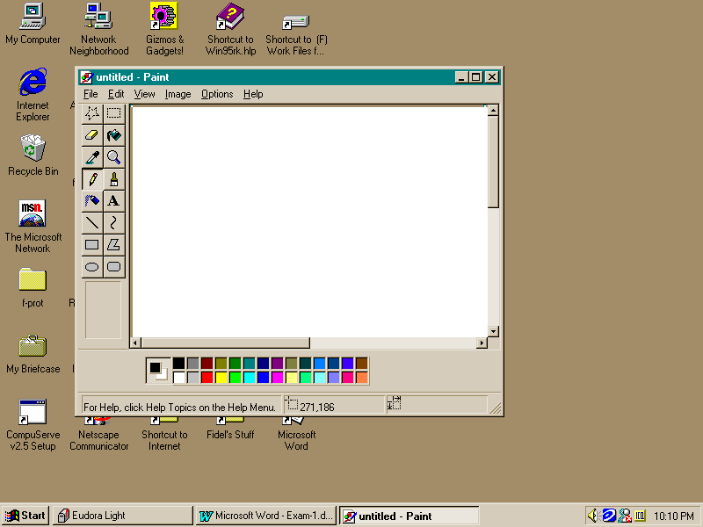

9.

11.

12

8

Minimize Button  File Folder  Program Icon  Task Bar  Horizontal Scroll Bar  Maximize Button  Title Bar ____________ | Vertical Scroll Bar  Menu Bar  Close Button  Start Menu  Desktop  “The Place where deleted files go” ___________

